**DBCP Documentation**

1. In homepage of DBCP project (http://dbcp.cuz.edu.cn/), click the ‘Source Code’ button to view the source code on Github.com.



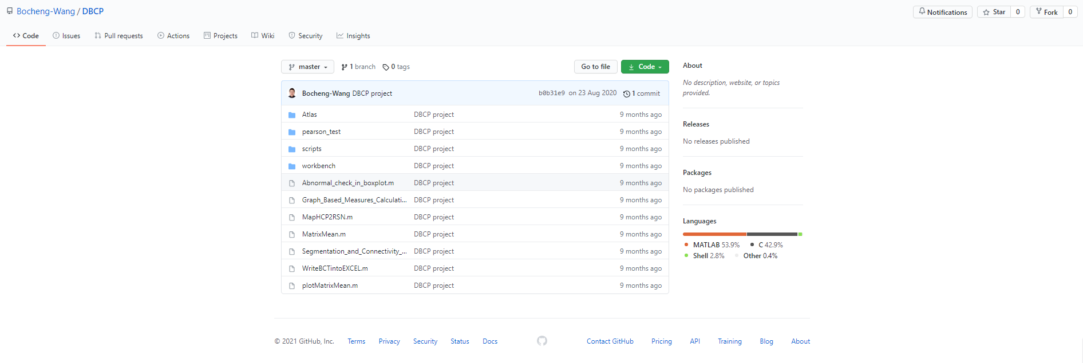

1. Choose Login in or Registration

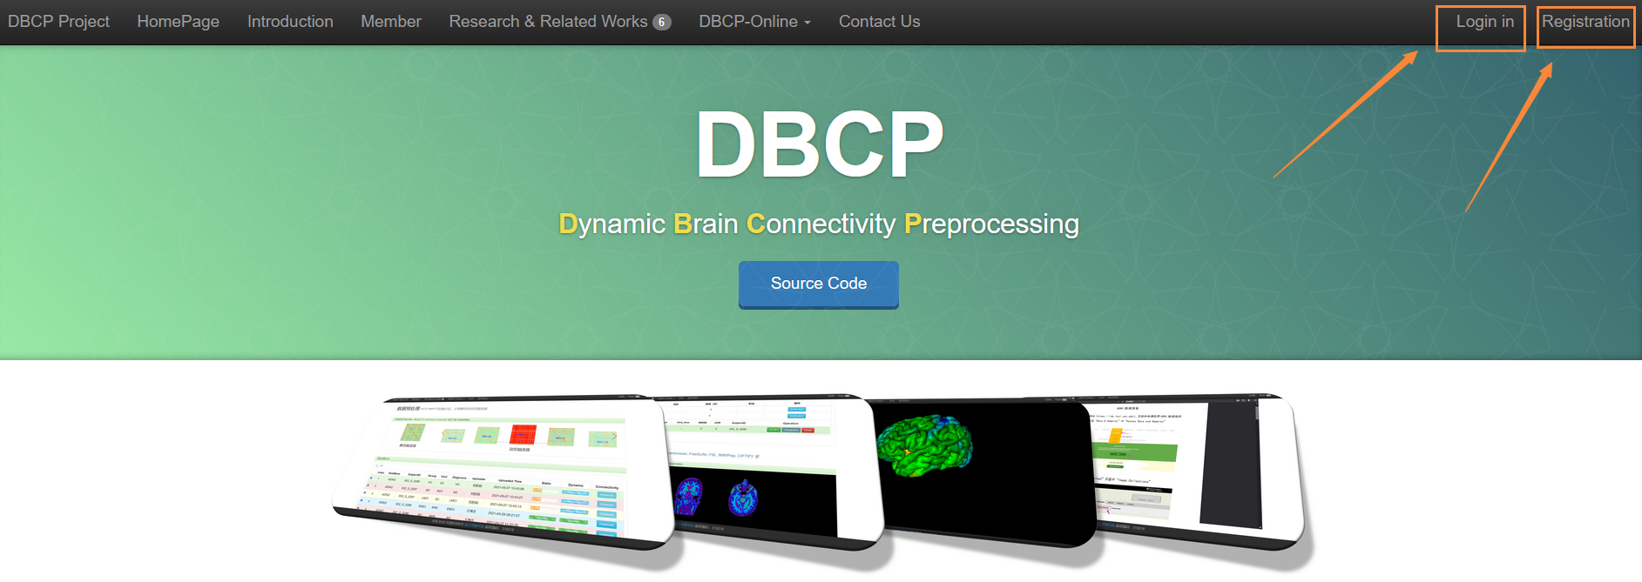

1. On the registration page, enter user’s name, password, confirmation password, email address, organization, usage, and verification code to complete the registration. The registration request will be automatically sent to backend website manager to confirm.

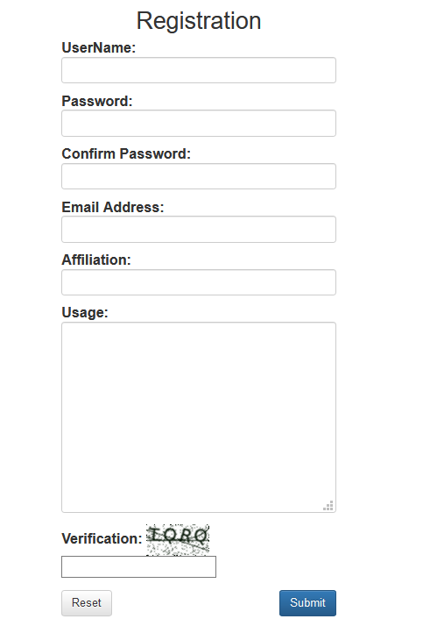

1. Enter the username and password to log in to DBCP

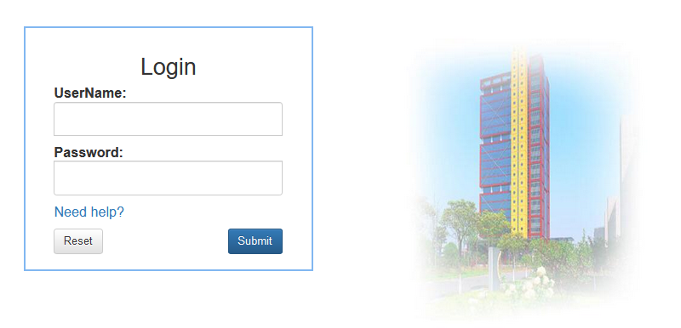

1. DBCP-Online Data preparation page will be displayed

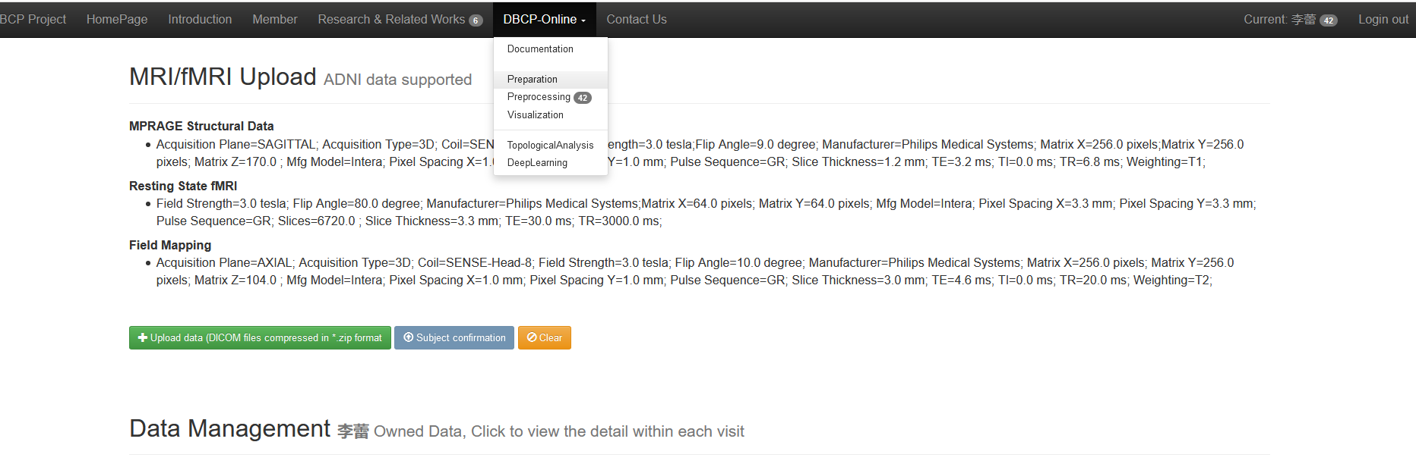

1. The interface is mainly divided into three parts: MRI/fMRI Upload, Data Management and Visualization. In the MRI/fMRI Upload section, click "+upload data (DICOM format compressed file,' *. zip')", and select upload compressed file in the pop-up interface. **The zipped file should be renamed as ‘ADNI version’ with the subject ID, such as ‘ADNI2_010_S_2131.zip’.** Incorrect naming would not be processed in DBCP.

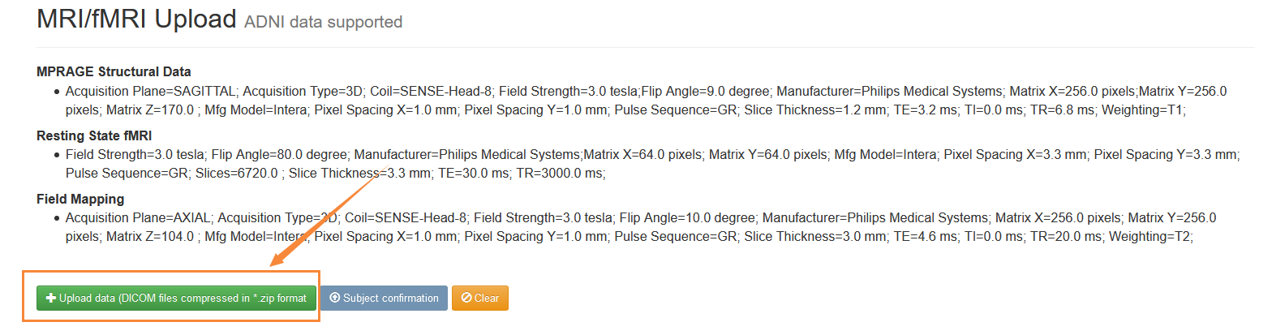

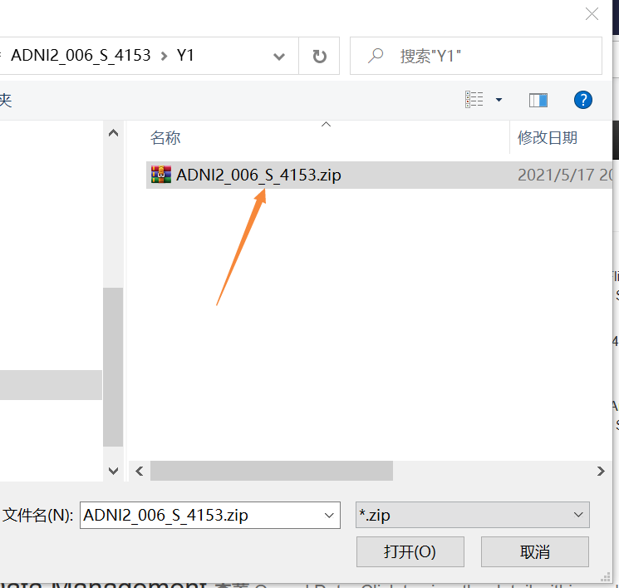

1. For the selected compressed ADNI data, fill in the information of clinical diagnosis, visit time and age, and then click "Start Upload" to upload the data, or click "Cancel" to cancel the upload.

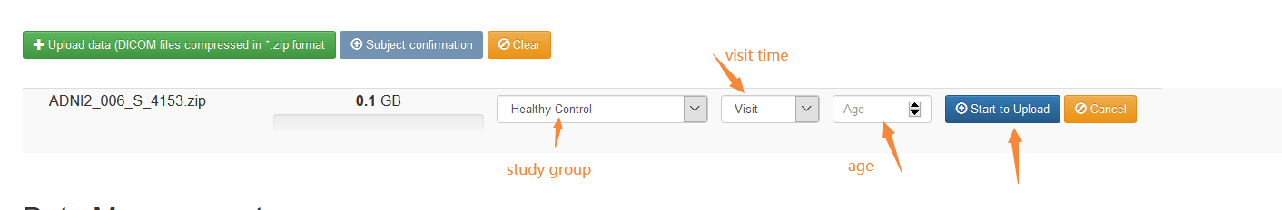

1. Check that the compressed file size ranges from tens of Mb to hundreds of Mb, and the upload time is about 10-20 minutes. After the data upload is completed, you can see the relevant information of the uploaded data in the Data Management section. Click the "Modification" button or the "+"on the left side to display the visualization and deletion operations.

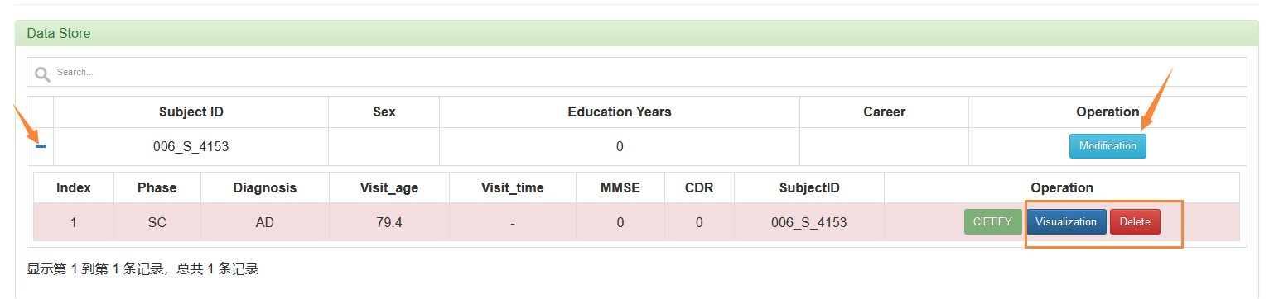

1. In the Visualization part, the corresponding side view, back view, and top view of the sample are displayed. The cursor stays on the corresponding sample legend to change the size of the sample. Click one sample icon to change the position of the red cross mark. You can see the change of the position of the corresponding red cross mark in the other two samples. Click the corresponding access operation to view the detailed information.

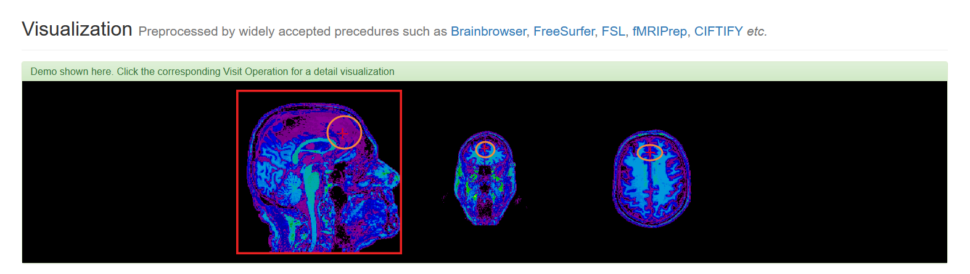

1. The Data Preprocessing interface is divided into two parts: Brain Connectivity and Preprocessing Queue.

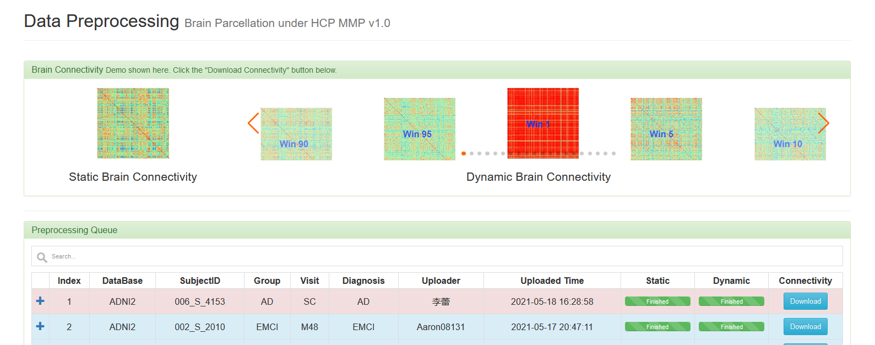

1. The Brain Connection part shows static brain connectivity and dynamic brain connectivity.

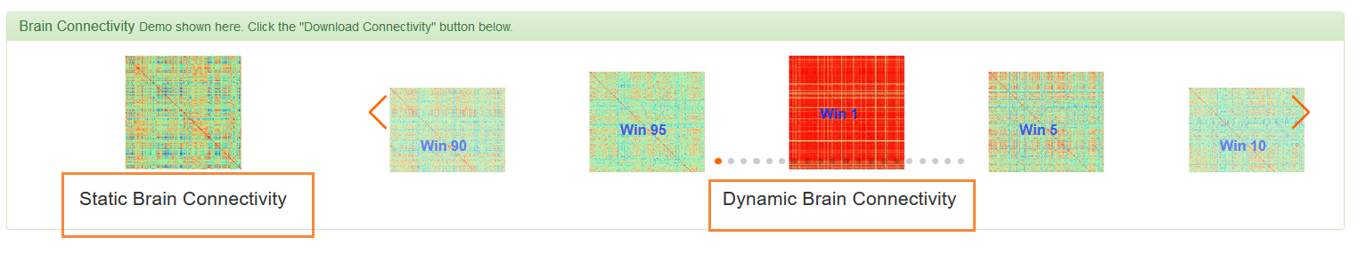

1. The Preprocessing Queue part can display relevant information of uploaded data and download progress of static and dynamic brain connection of uploaded data, and the preprocessing time is generally 4-6 hours. Click the Download button to download the brain connectivity data.

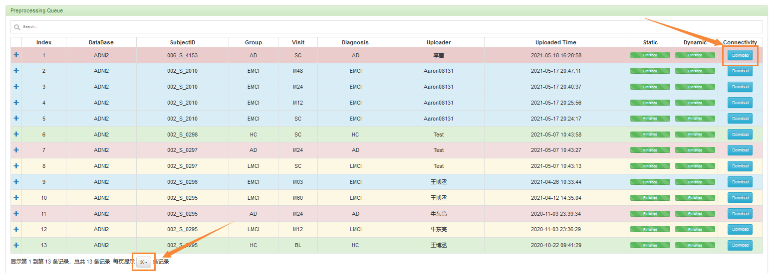

To be continued…